Name ____________________________
1. State a possible function that yields the following graph.
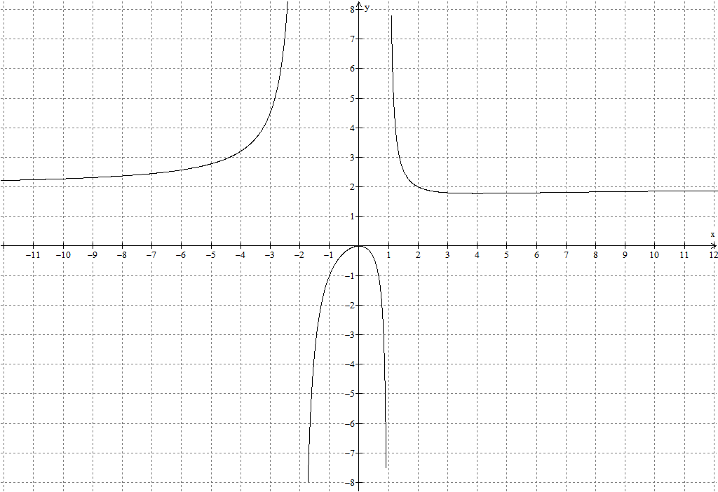

For each of the following, state the vertical asymptote(s), horiziontal asymptote, and zero(s). Sketch a graph with correct asymptotes and any holes labeled (with its coordinates). Check your answer by graphing on your computer or calculator. Take advantage of the CAS system on your calculator to help. Caution: you really need to check these as there are a couple of surprises.
2. 3.

4. 5.

6. 7)

8) Now for a tricky one: .

9. Challenge: a) Graph b) Solve:
Selected Answers
1)
3) VA: HA: Zero:
5) VA: HA: none Zero:
7) VA: HA: Zero: Hole:
9b) or

